**QUIZ: CITIZENSHIP, IMMIGRATION, & VALUES**

**1) Someone who is legally a member of a country is considered a(n):**

A) Immigrant C) Citizen

B) Alien D) Resident

**2) Who is eligible to become a naturalized citizen of the US?**

A) Someone born in the U.S. C) An illegal alien living in the country

B) A legal alien or resident living in the country D) Someone born to American parents

**3) A person born in Texas to non-citizen parents would be considered a US citizen because of:**

A) The Law of Blood C) Naturalization

B) The Law of Soil D) They wouldn’t have citizenship

**4) Juliet is born in Cuba to non-citizen parents who moved to the United States at age 22. How would she be considered a US citizen?**

A) The Law of Blood C) Naturalization

B) The Law of Soil D) They wouldn’t have citizenship

**5) A person born in Puerto Rico to non-citizen parents would be considered a US citizen because of:** A) The Law of Blood C) Naturalization

B) The Law of Soil D) They wouldn’t have citizenship

**6) Tom is born in Russia to a mother who was born in Florida and a father who is a Russian citizen. How would Tom be considered a US citizen?**

A) The Law of Blood C) Naturalization

B) The Law of Soil D) He wouldn’t have citizenship

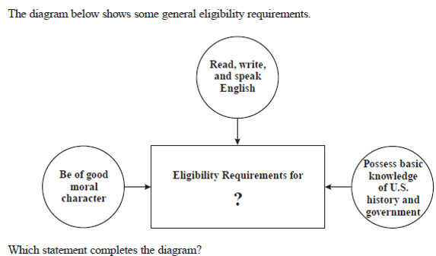

**7) What statement best completes the question mark in the diagram to the right?**

A) Joining a military service

B) Volunteering for a political party

C) Becoming a naturalized citizen

D) Obtaining a driver’s license

**8) All of the following are fundamental American values EXCEPT for:**

A) Liberty C) Equality

B) Citizenship D) Justice

**BONUS) Do you want a free 20 points on this quiz?**

A) Yes

B) No